Oop concepts
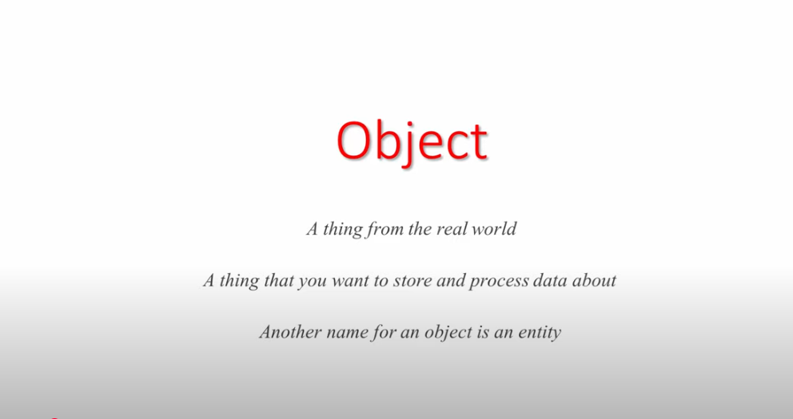
Data abstraction

class is a template for creating objects
basically class is dedfined to create the attributes and functions of the object
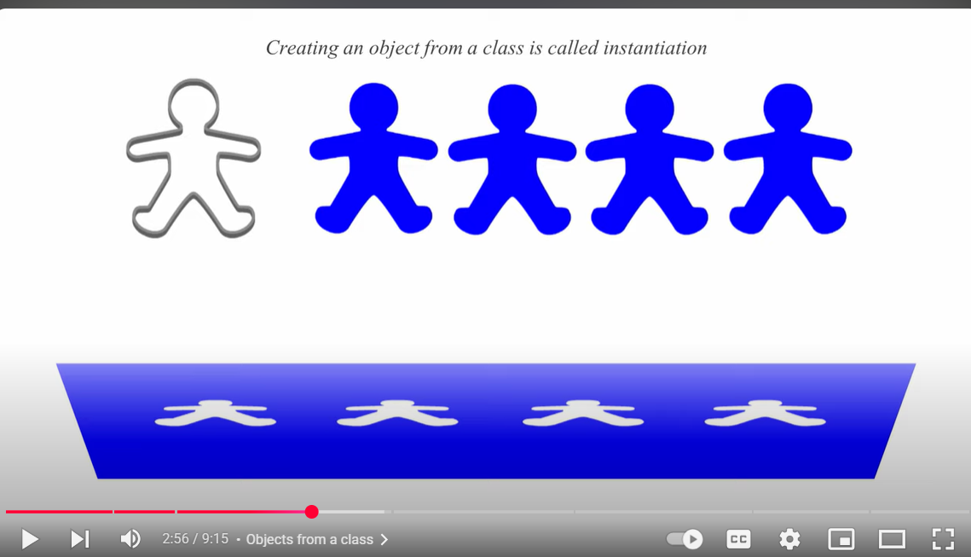
An object represents the state and behavipur of the class and insatcne is the copy of thr clas that epresents the object

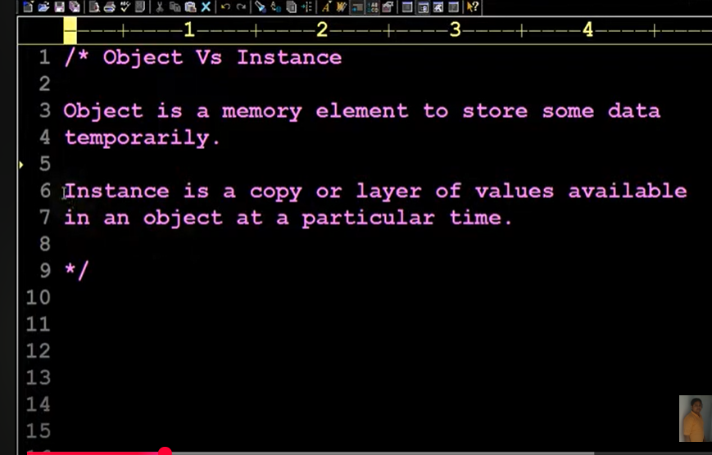
Encapsulation
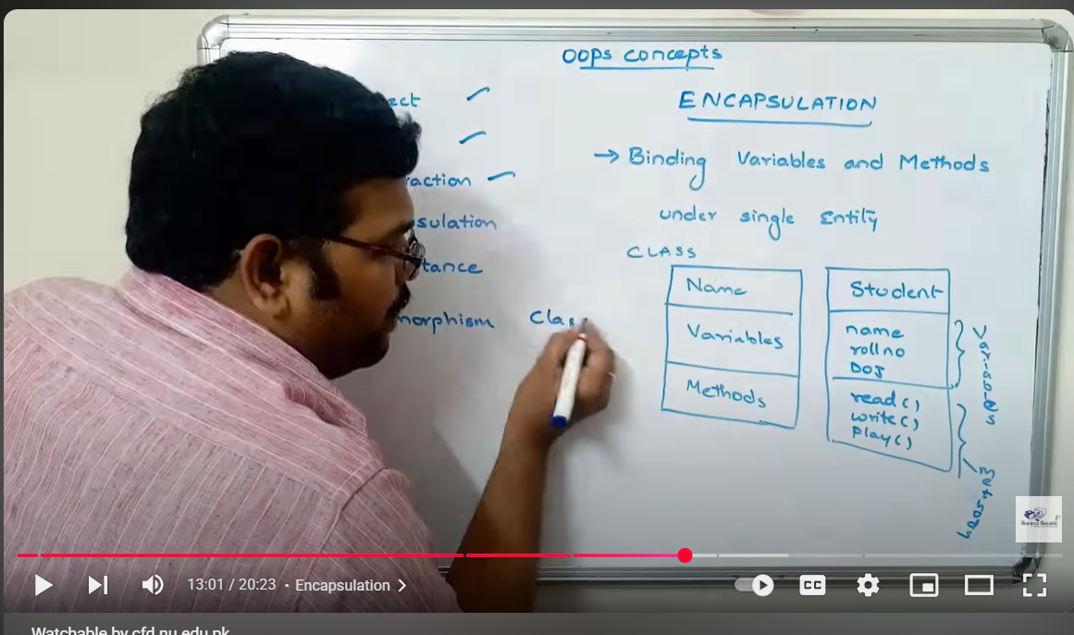
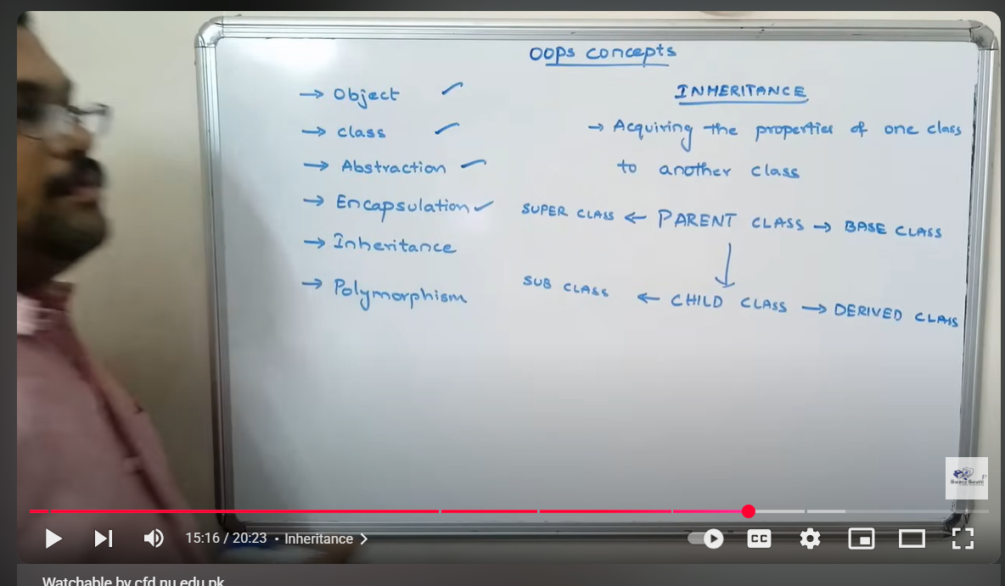
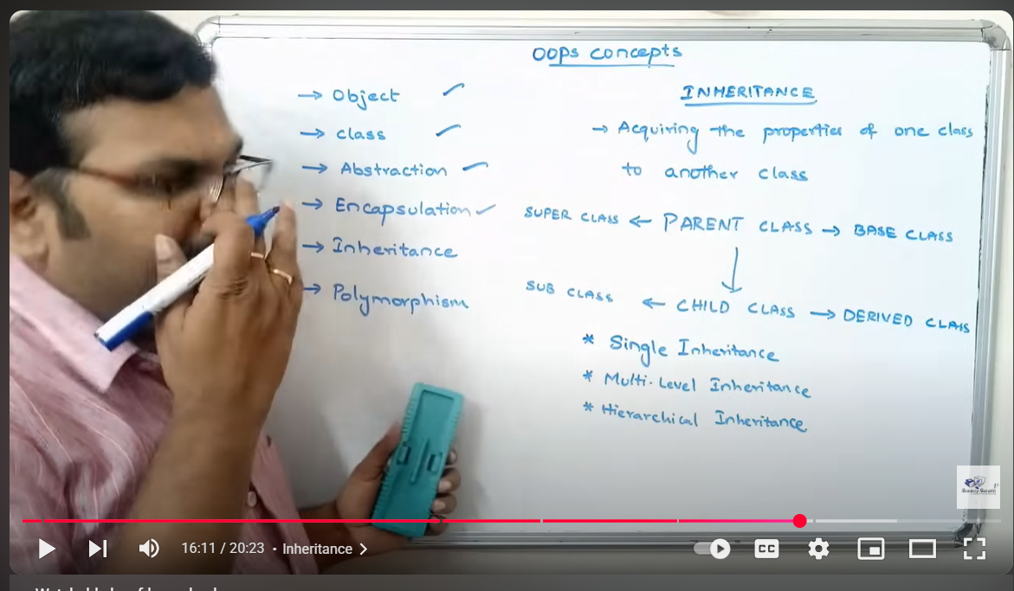

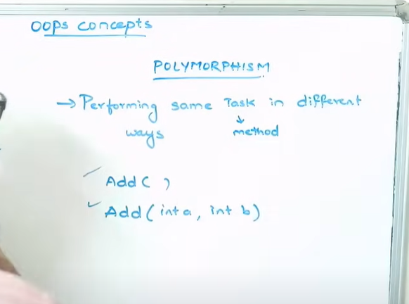
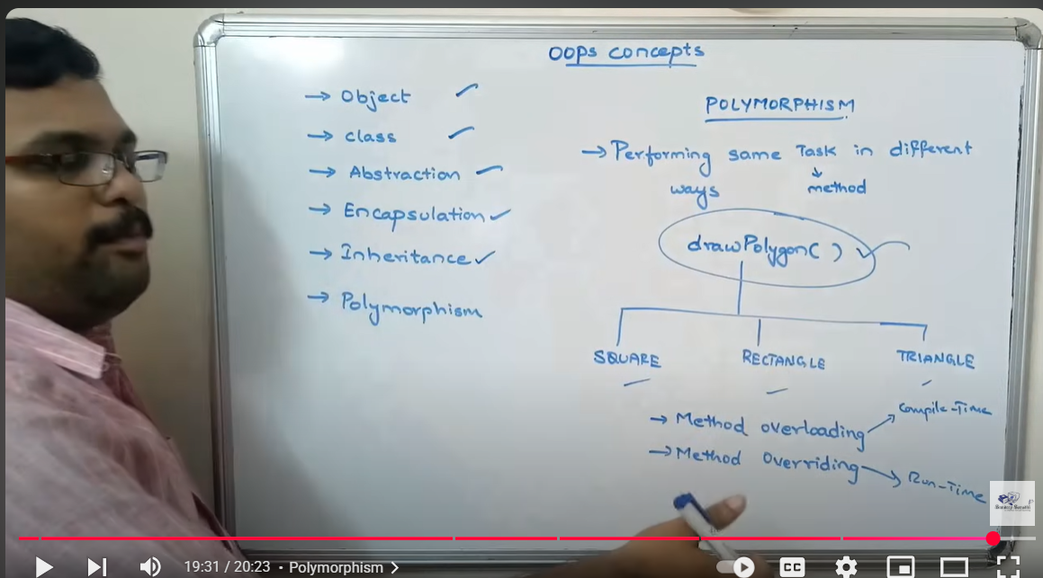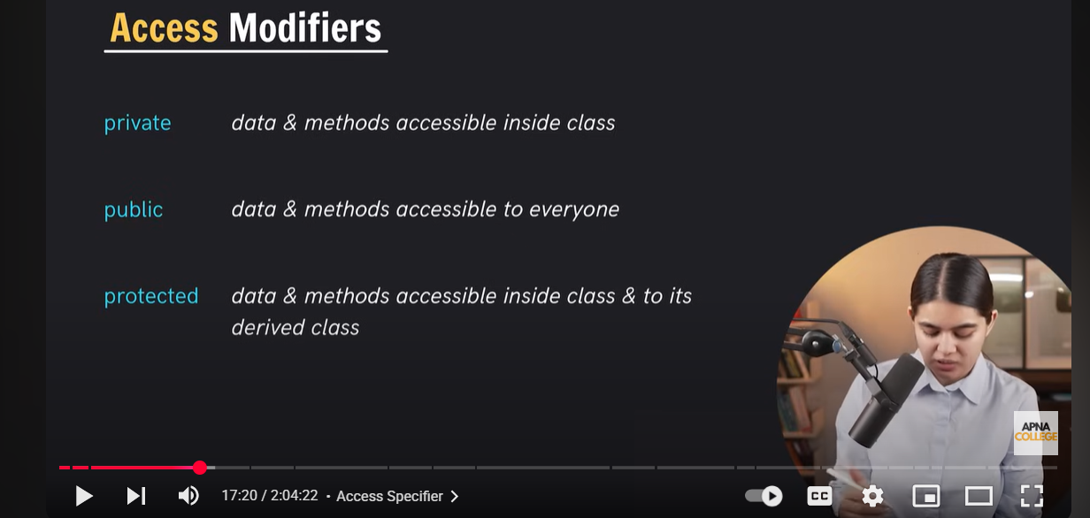
Protextred is basicaaly used in inheritance gab ham derived class mai parent class kai attribites use krnay ho to us ko access krnay liye parent class mai attribites protected bnaye gai wo attributes sirf derived class mai access kr saktay hai class sai bahir nhi agar wo protected hai to
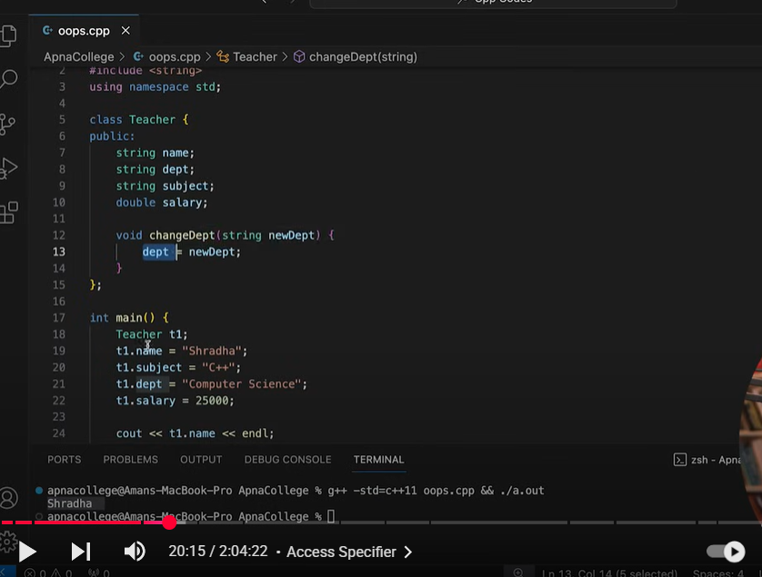

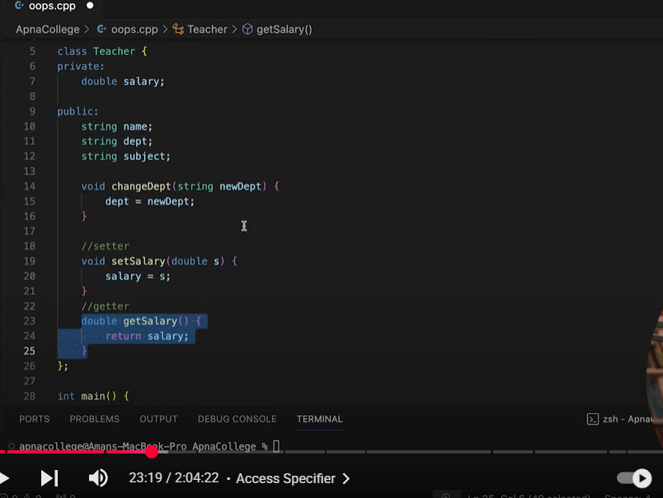
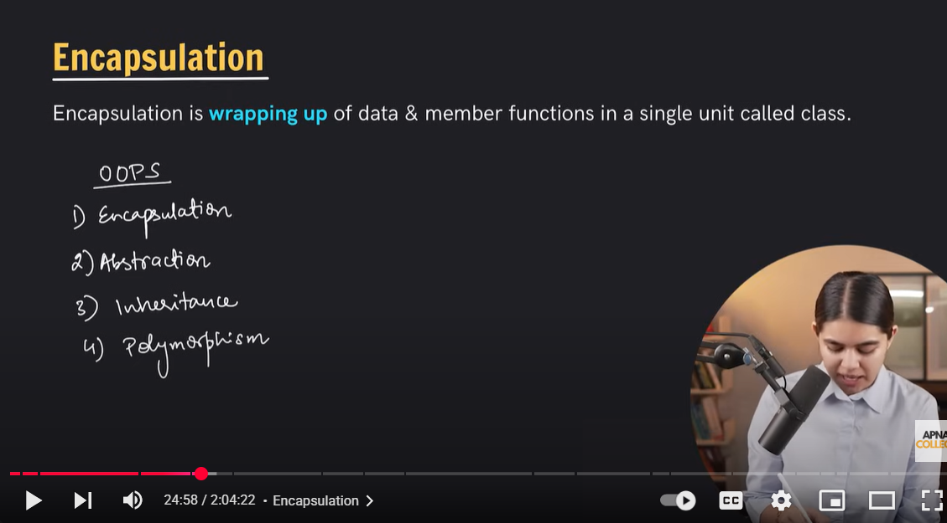
data hiding
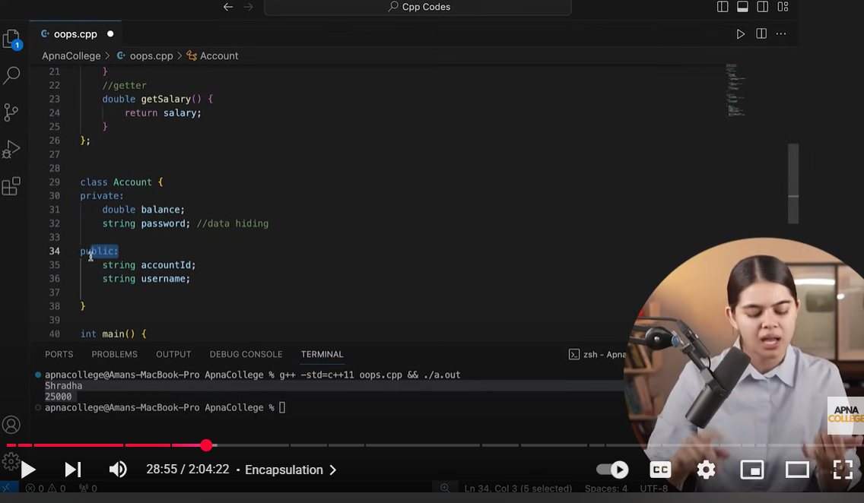
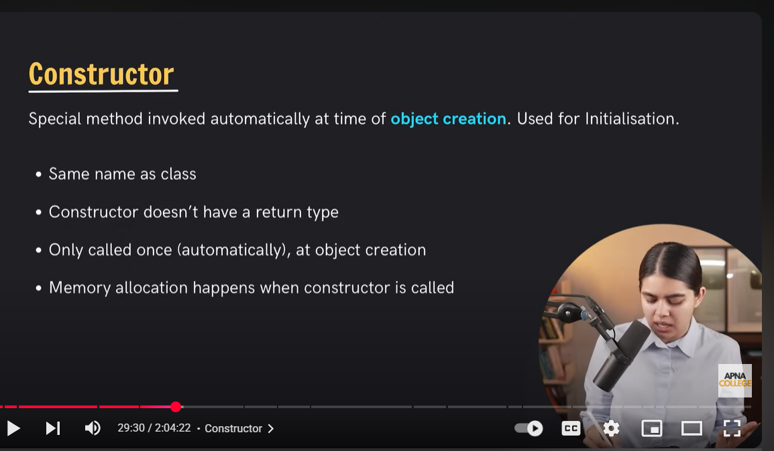
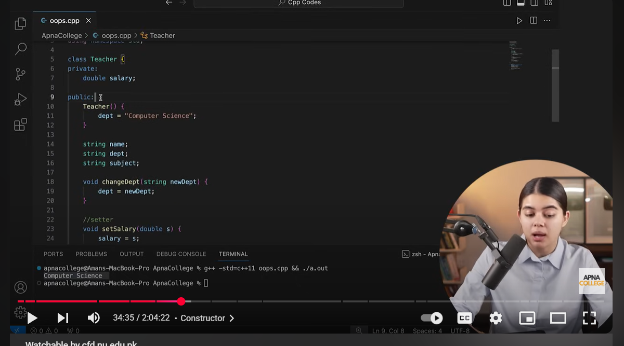
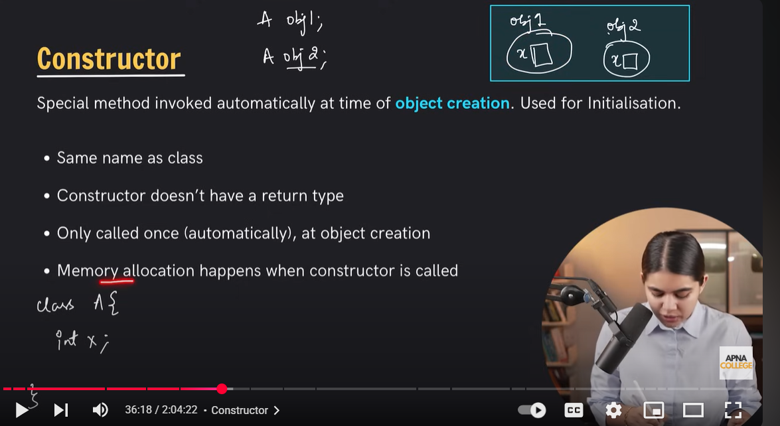
memory allocated when the constructor is called
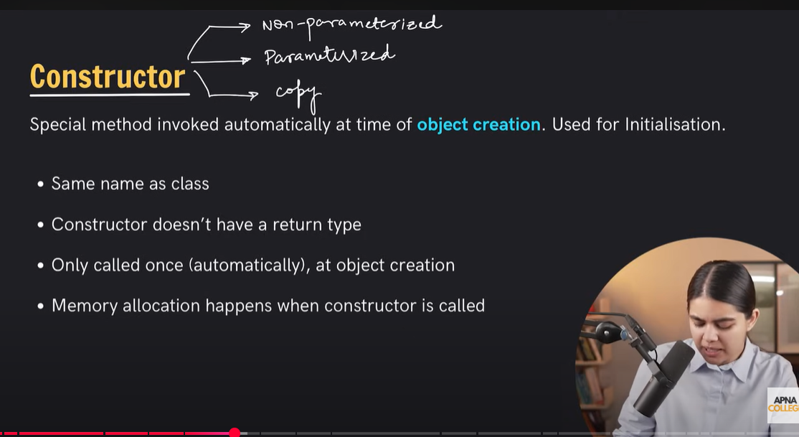
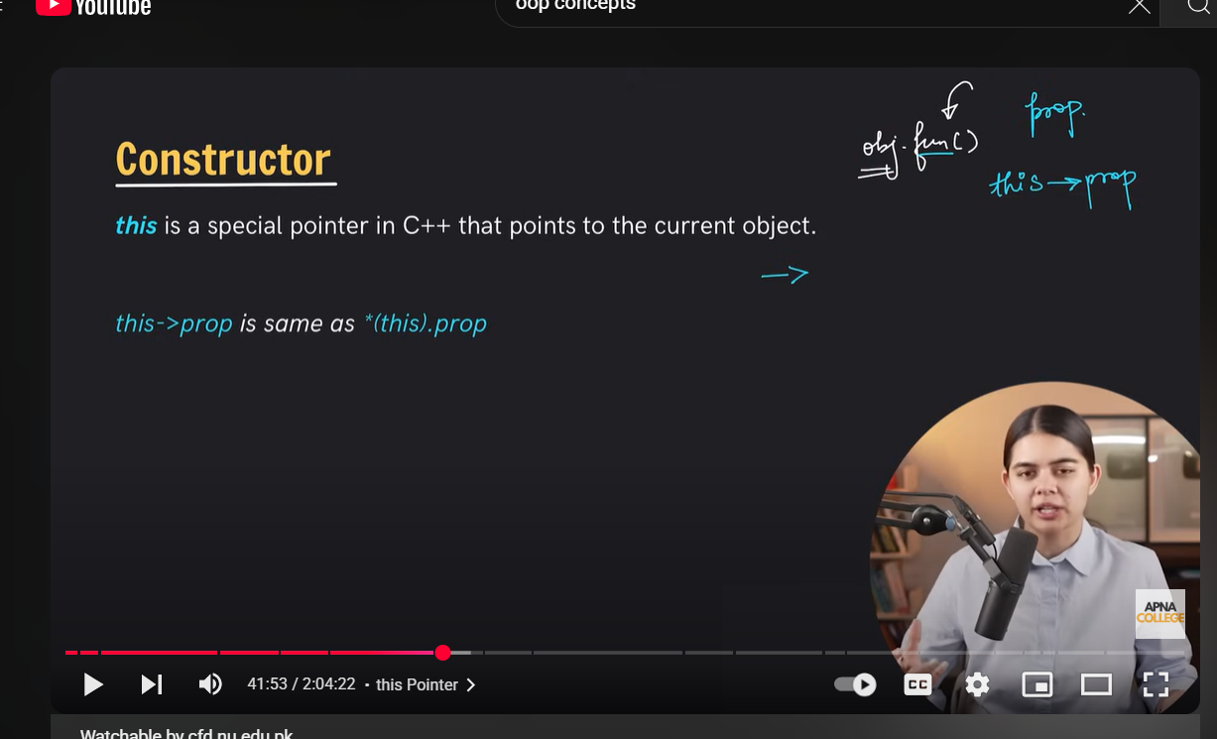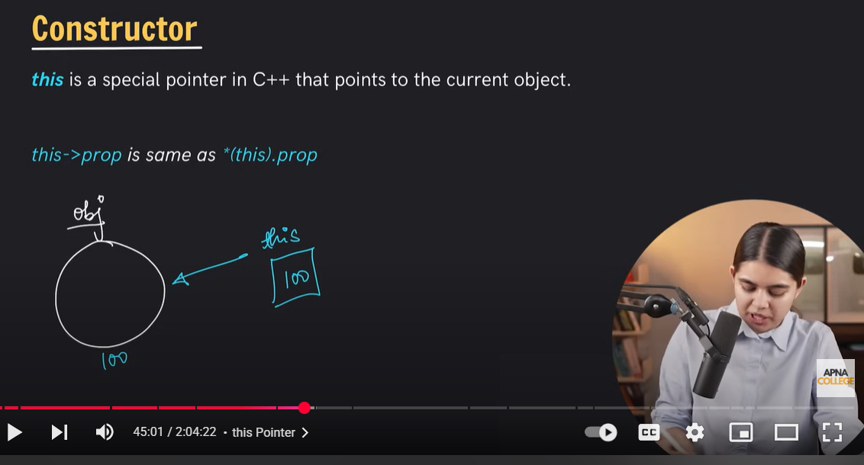
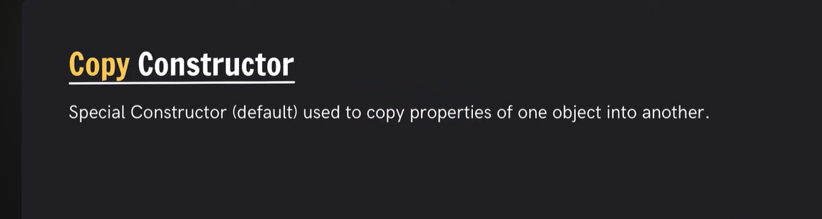
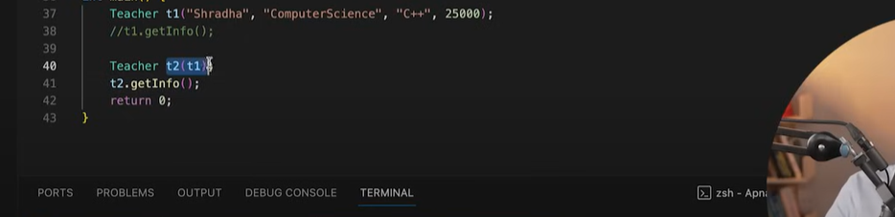

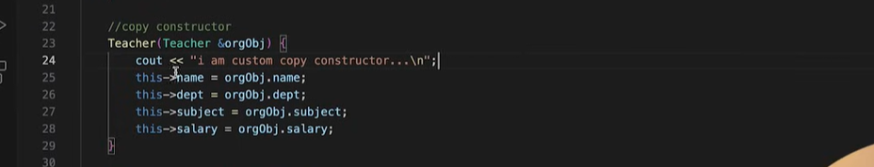
copy constructor uses shallow copy the problems occurs in shallow in case dynamic memory allocation mai same value copy ho janti hai agr aik ki change kro to dosray ki bhi change jho gati hai to hamay is liye deep sopy krni chahiye us kai liye compiler hamay default constructor provide nhi krta is liye hamay apna bnana parta ha heap mai duplicate kr kai aik naye memory alloate kr kai us ka refer kro
voice on my whsatpp gam dyaimcally meomery use hoti hao to deep copy ka constructor likhna parta hai
deep copy
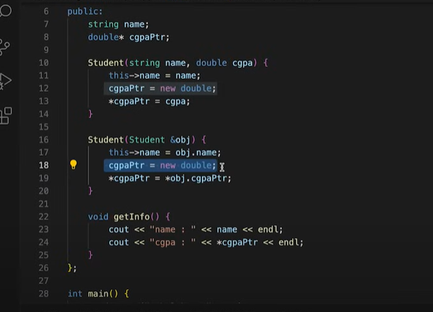
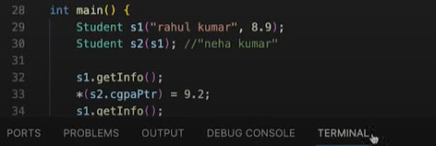
copy constructor mai cgpa ko doabra sai new memory allocate kr rahay heap mai phir cgpa ki value ko us mai copy kr rahay hai
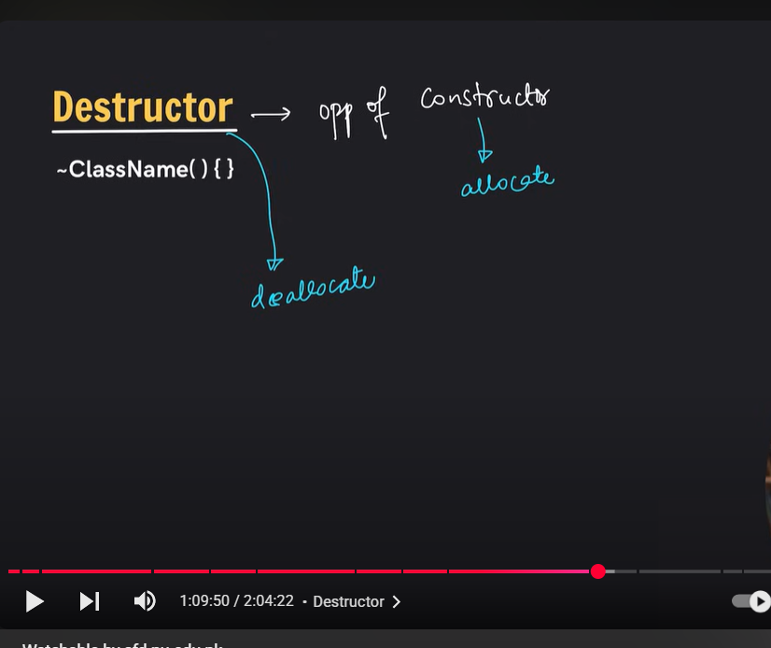
Static deallocation compiler by deault khudi kr daita hai likin gan ham new keyword sai dynamic memory allocate krtay hai to us ko deallocate kr kray kai liye hamay explicit delte ka keyword use krna parta hai
destructor khud by khud call hp gata hai agar ham delete nhi krai gai to memory leak ki problem asakta hai
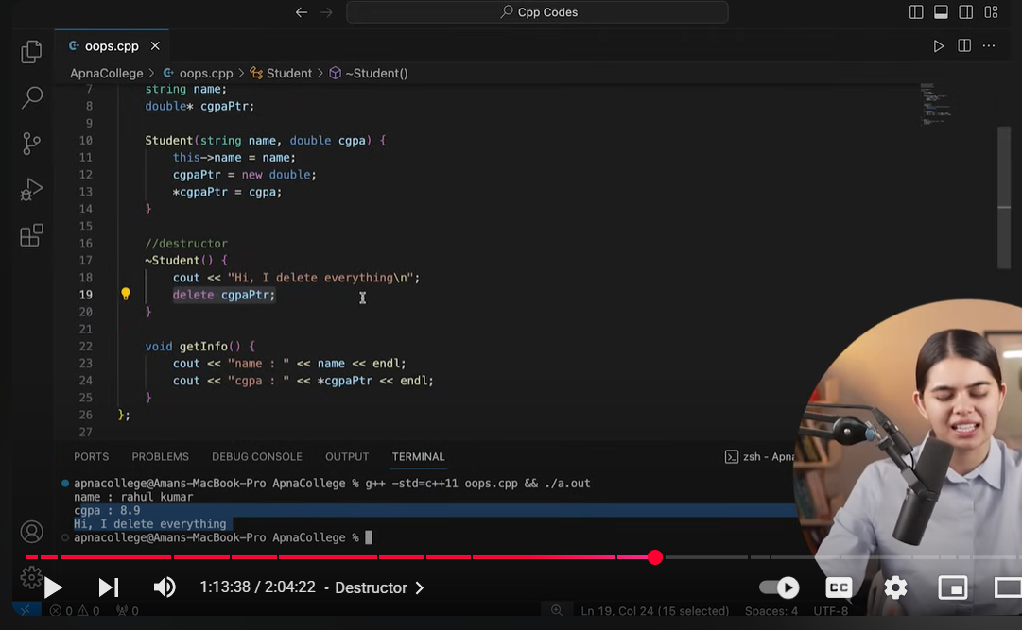

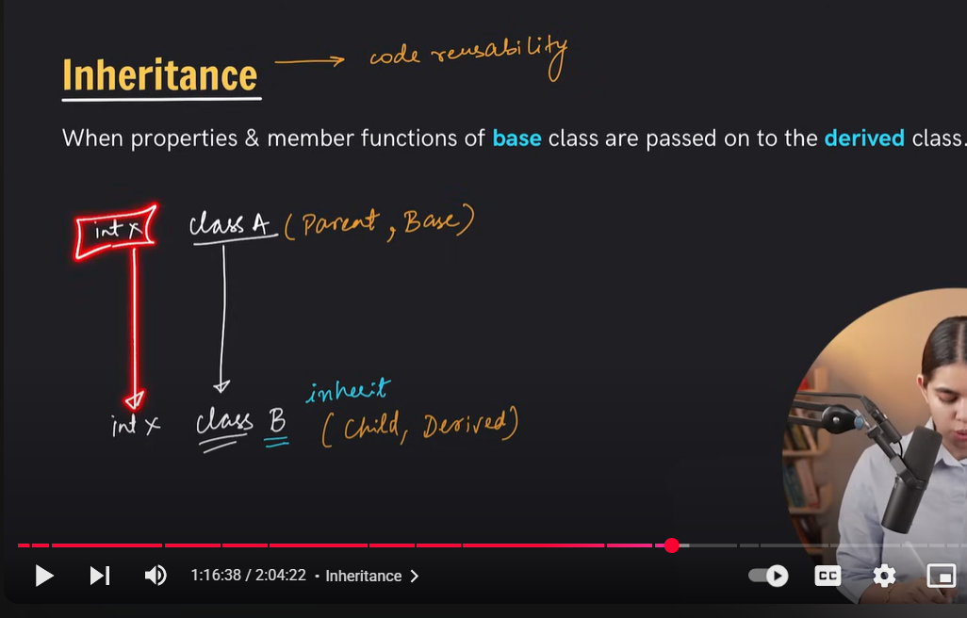

Inheritance
parent class ka constructor pehlay call ho ga phir child class ka constructor call ho ga
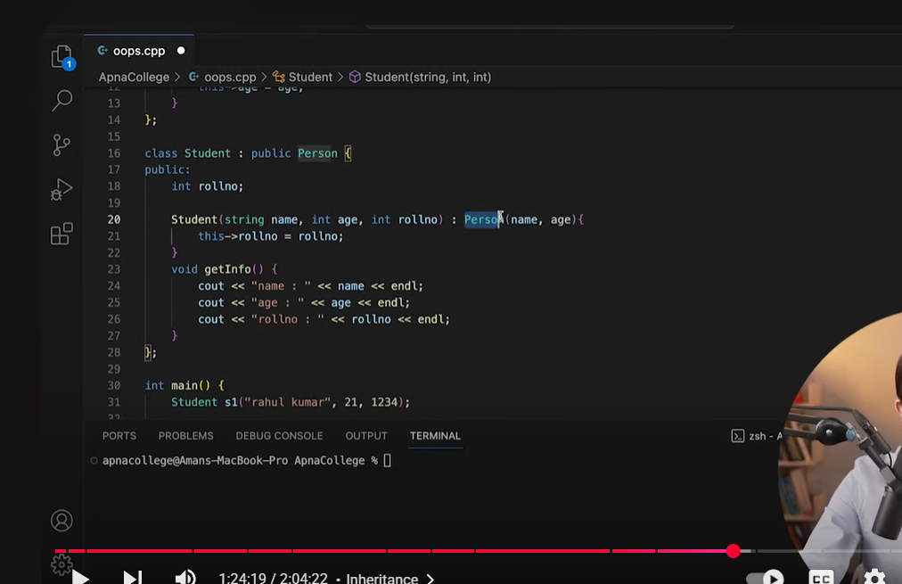
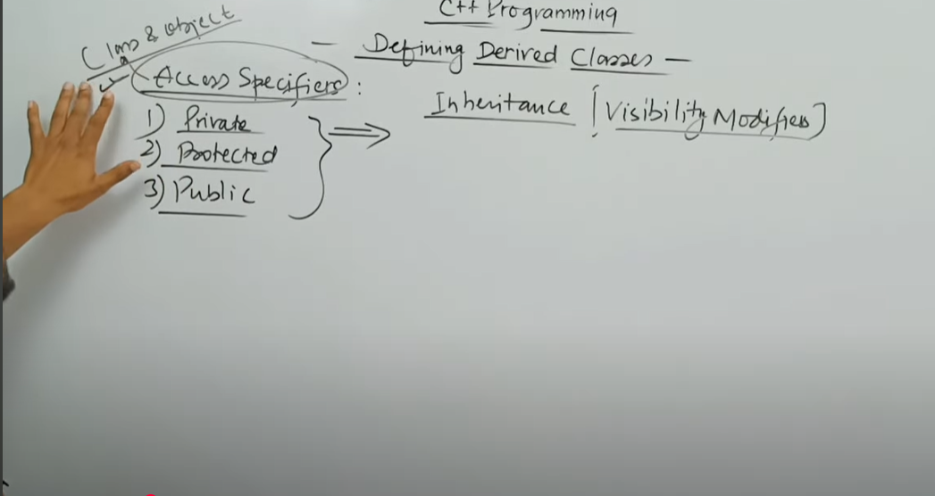

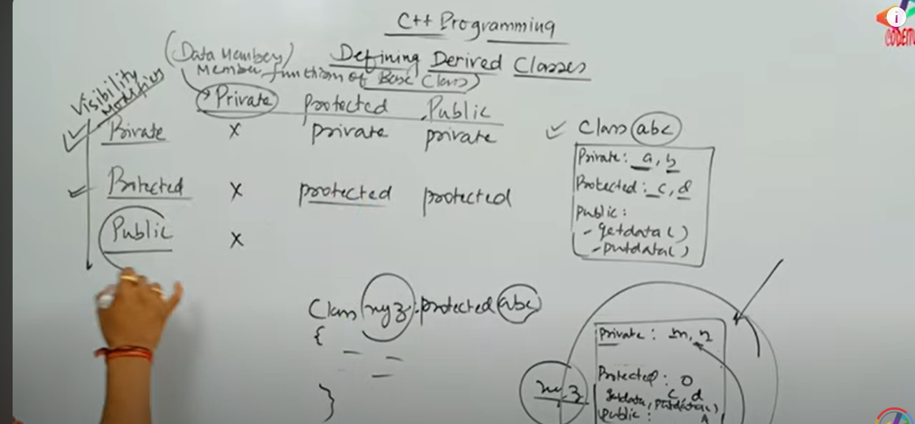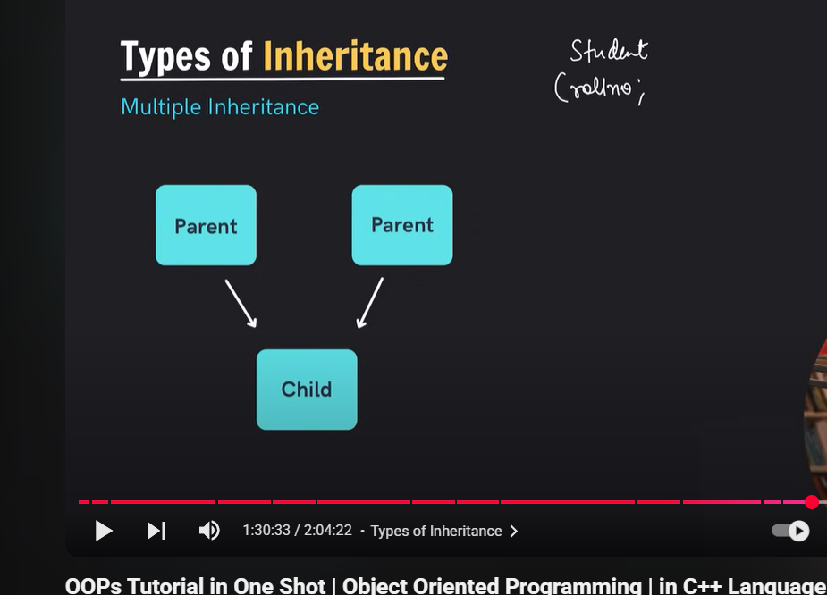
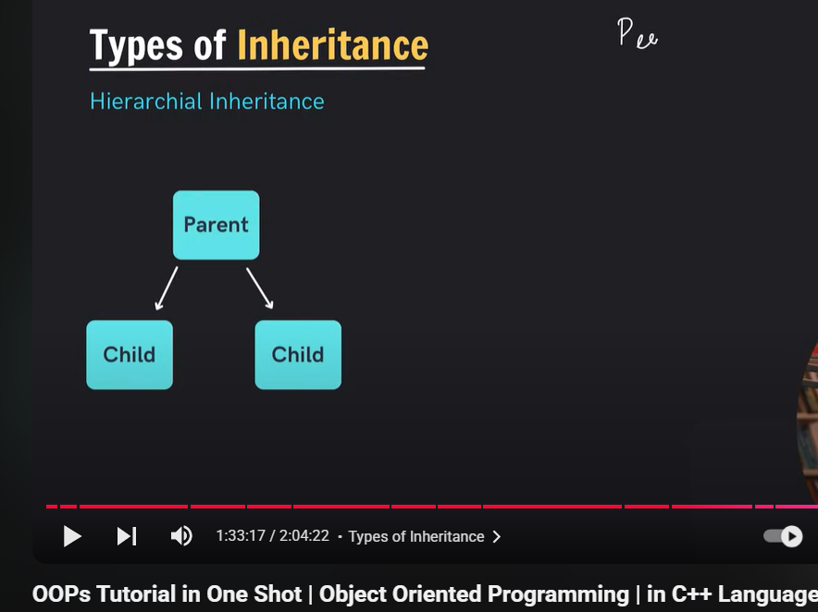

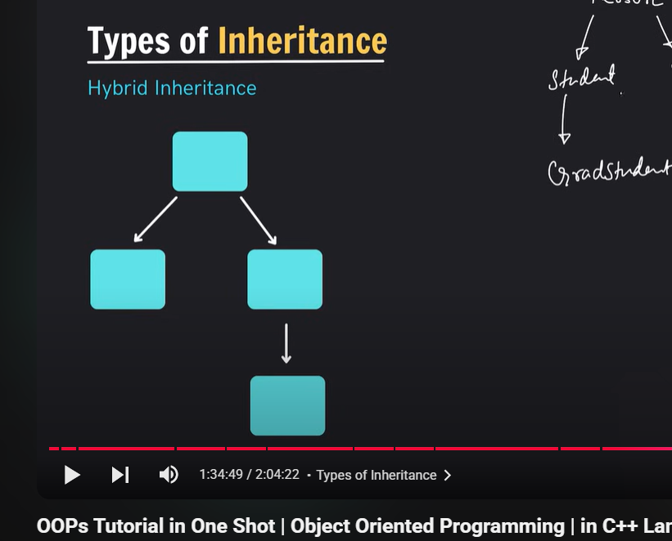

Diamon roblem occurs in multiple inhheritance

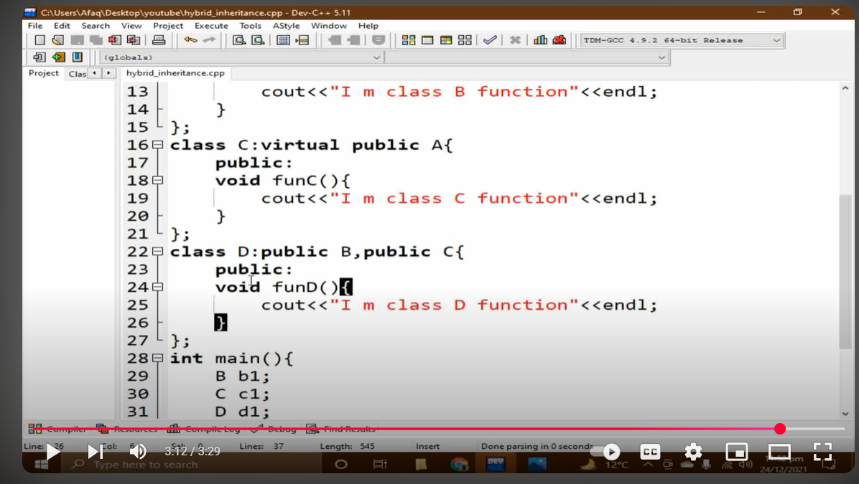

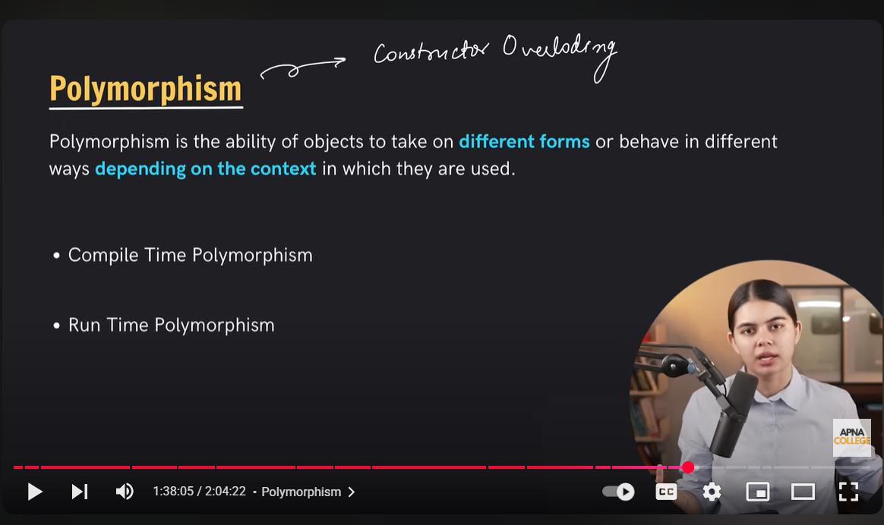

Compile time polymorphism
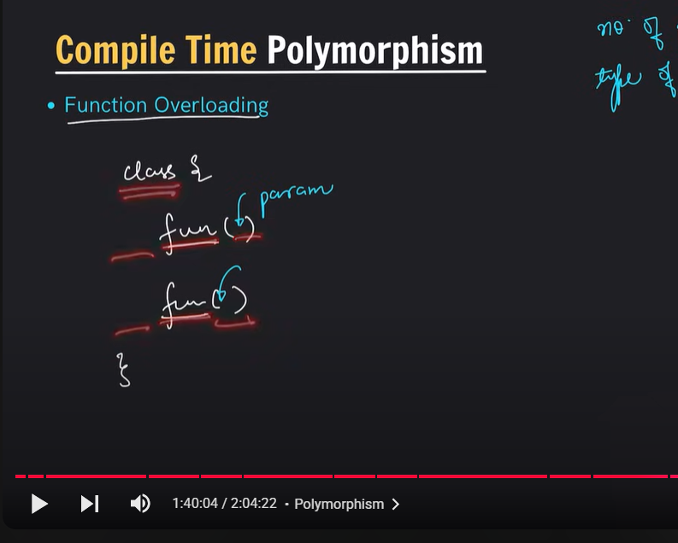
return type same ho ya differ us sai farak nhi parta bs no of parameters change honay chahite ya data type
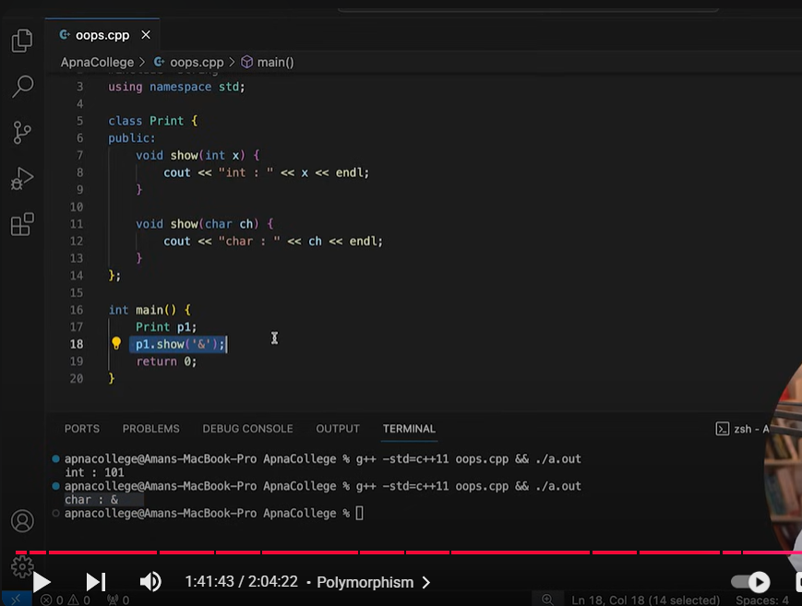
Polymrphism allow object to bahev in differernt way like depends upon the context
operator iverloading
function overloading
operator overloading
same name sai bnatay haui ya number of paremters ,ya parameter kis datatype sai differentiate hota hai object agar parameterized hai to parameter wala call kr do ya us ka parameter kis type k ahai us type ka call kr do polymorphism depend upon the calling object
deep copy hsaloow copy concept copy constructor gab statsically memebrs use krr rahay stack to masla nhi krti shakkow copy same memory ki cpy ban gati hia addresses dono ka same rehta hai lekin agar dynamically ememory heap use ho rhai hai datamember koi pointer ya array bnaye hia to waha shallow copy sahi nhi shallow copy kai by default copy construtpr call hi gata ha ilekin dynamically gab ham use krtay hai to ahmay copy constructor manually bna saktay hai apna pointer bna kai usay mai ham variable sai data copy kr kai waha store kratay hai pointer ko refer nhi krtay poranay variable ki taraf gaha sai ham nai data copy krna ho balkai pointer kai variable mai store kratay wo value phir aik value change krnay sau dosri value change nhi hotu or destructor bhi dynamically hamay khuid invoke callkrana parta hai dynamically memeory kai liye
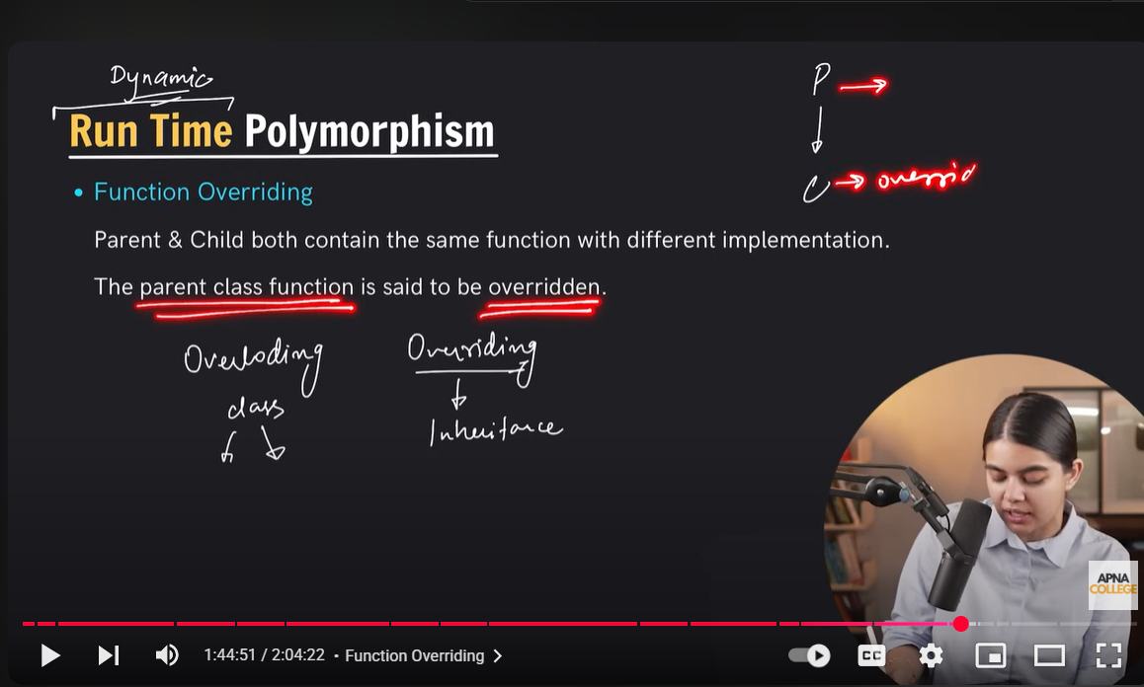
runtine poly mai function overriding or virtual functions atay hau
compile time mai function overloading and operator overloading atay hai
function overloading ka matlab aik hi class mai same name kai function banan parameters ya type change ho
function overloading inheritance kai case mai hoti gab class b inherit ho class a sai to us mai ham same name kai functions bna sakty hai parmters bhi same dai saktay hai type bhi same dai saktay hai kon sa function call ho ga yai depend krai jis class ka object create us ka function call ho gaye ga
virtual functions ak matlab hai kai derived class isay dobara sai redefeined kr sakti hai or virtual keyword ham lagatay hai base walay function kai sath is tarah child class same function ko dobara sai redefined kr sakri hai works similar to function overriding

function overriding mai ham pointer nhi bnatay
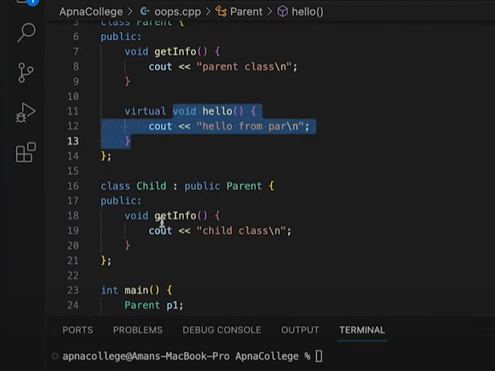
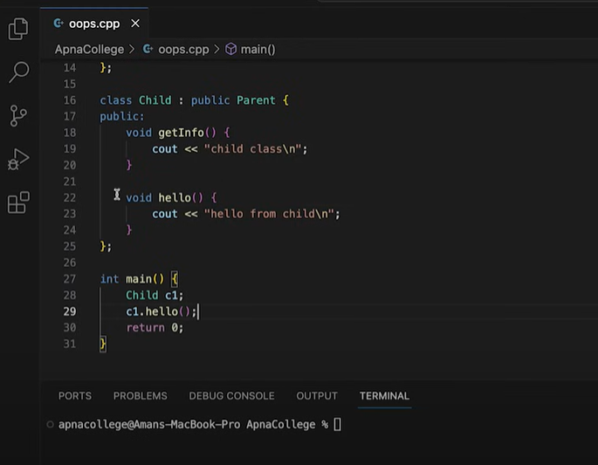
aik or baat agar base class kai destructor kai sath virtual na laga ho to hamesha base class ha hi destructor call ho ga (imp )child class ka nhi virtual use krna chahoye destructo kai sath bhi ta kai child class mai bhi ememory leak na ho child class ki bhi memory deaoolacte ho gi phir

ABSTRACT CLASS KA KOI BHI OBJECT NHI BNATA BAS YAI
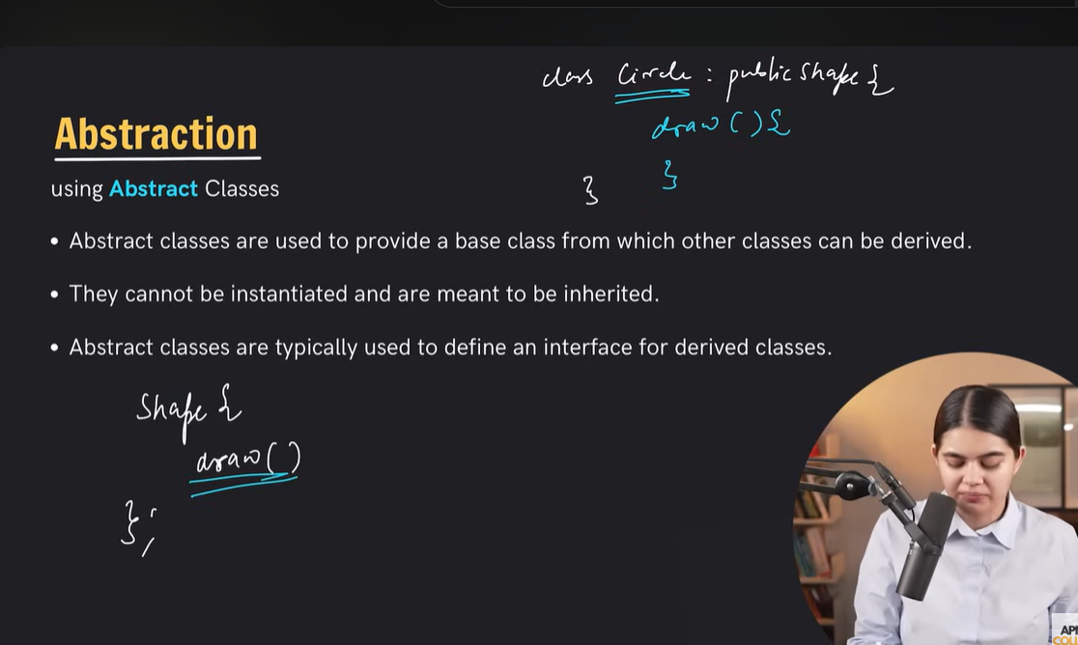
Pure virtual functinos sue in abstract classes
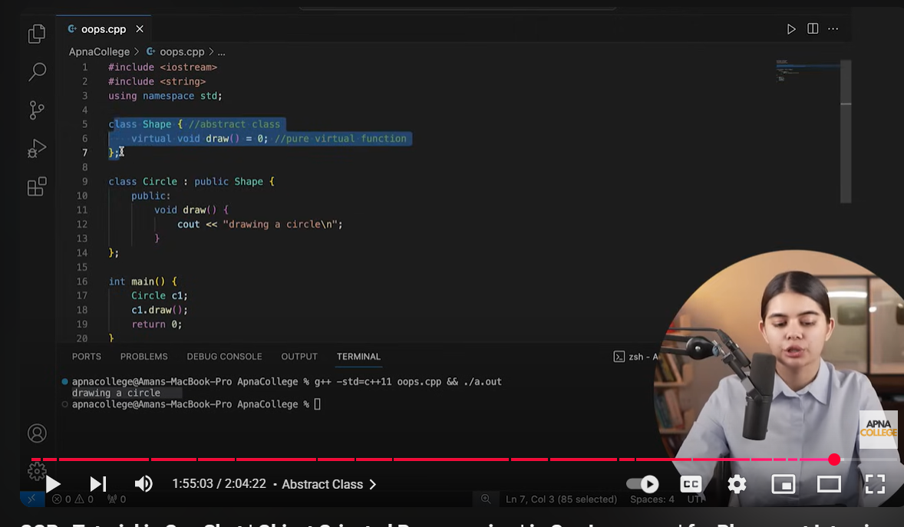

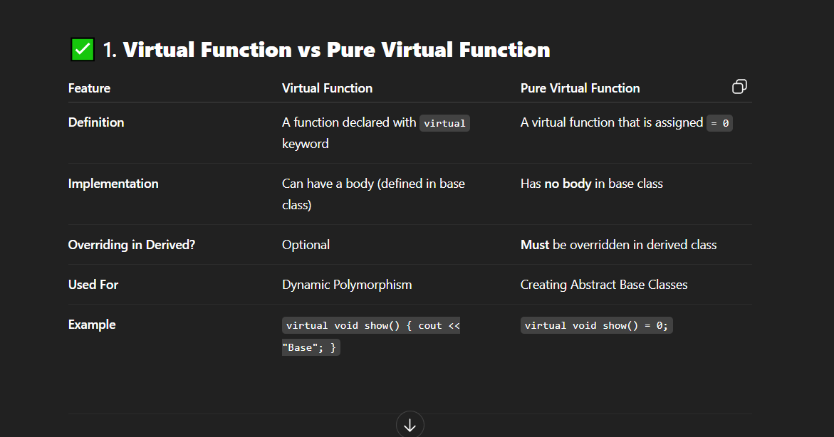

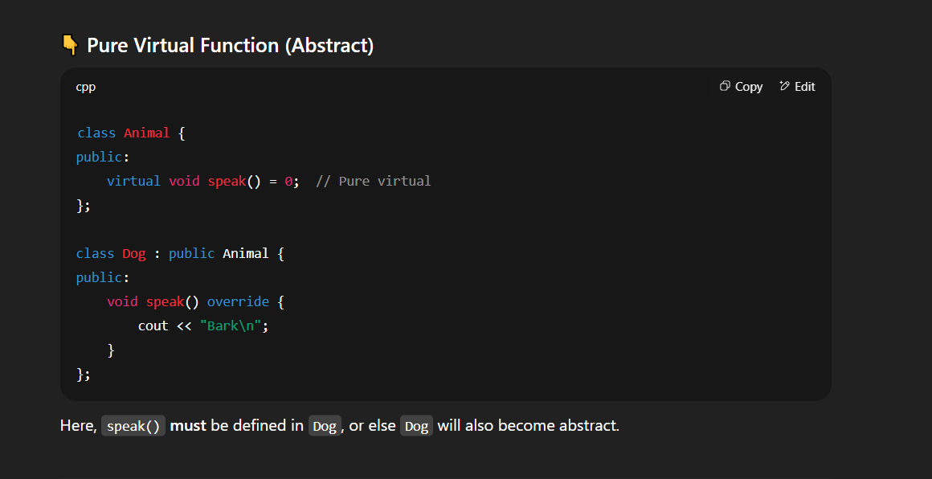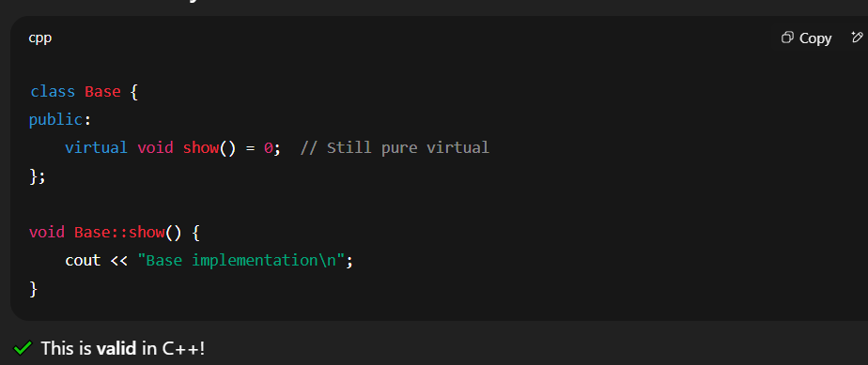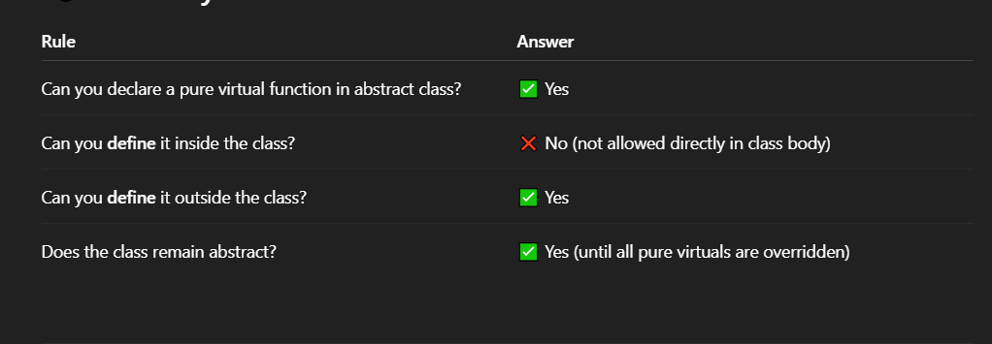
Friend function allow krta hai outside of the class kai private datamembers ko access kr sakay is tarah class mai decare krna parta hai friend keyword kais sath likin is ka yai matlab nhi kai yai function us class ka member function bn gata ha9
Aisa bilkul nhi hota ai aik simple function hota hai is liye ham isay class kai object kai sath cal nhi kr saktay gaisay ham member function ko krtay hai is function ko ham declare class kai public part mai bhi kr saktay hai private part mai bhi
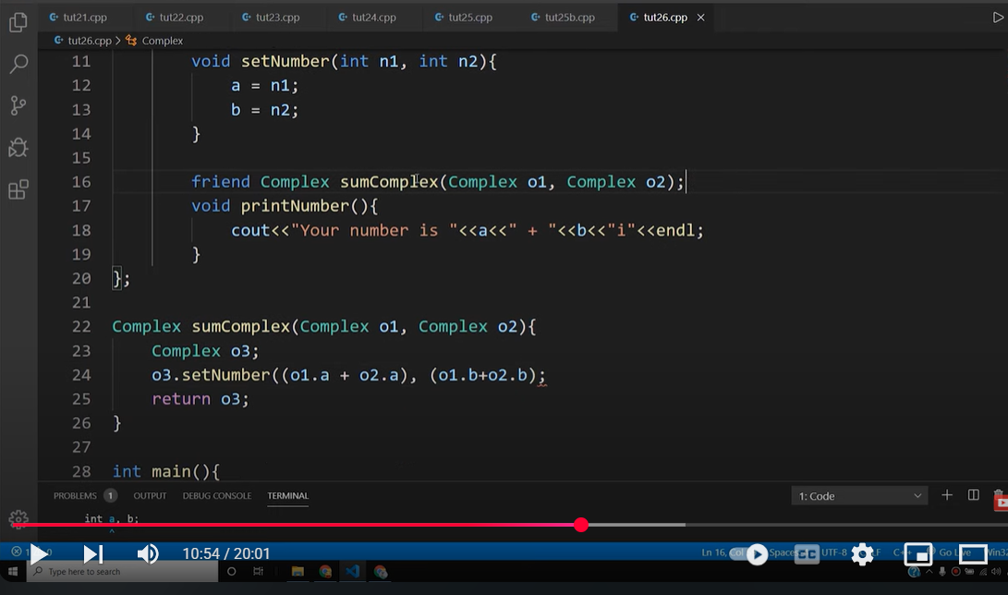
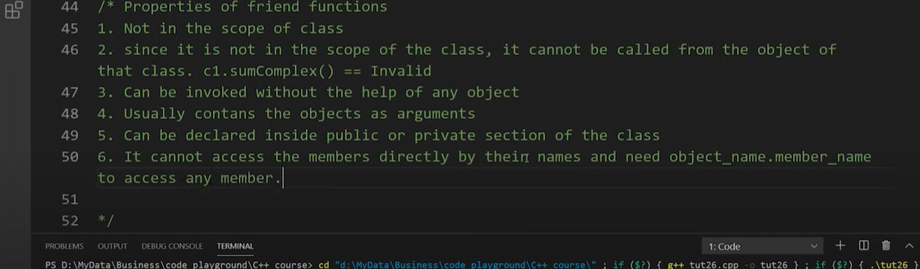
cant access the directly ut gives you error can only be access by obj.memberfunctio()
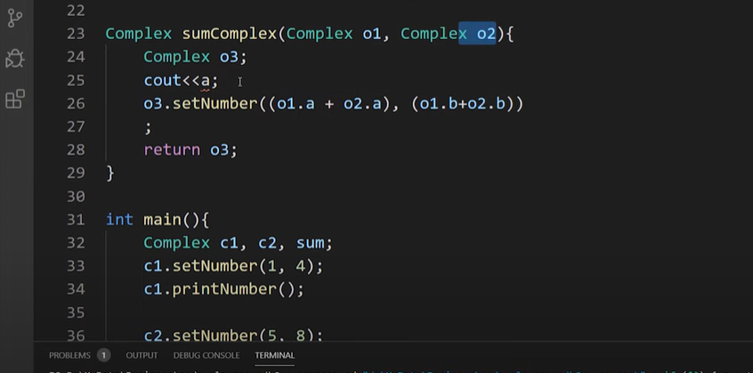
forward classes agar ham nai kisi A class kai saray function class b mai use krnay hai to ham class b mai a kai friend class a likhay gai to Class b ka friend ban gaye ga class class b use kr sakta hai saray priv data members ko
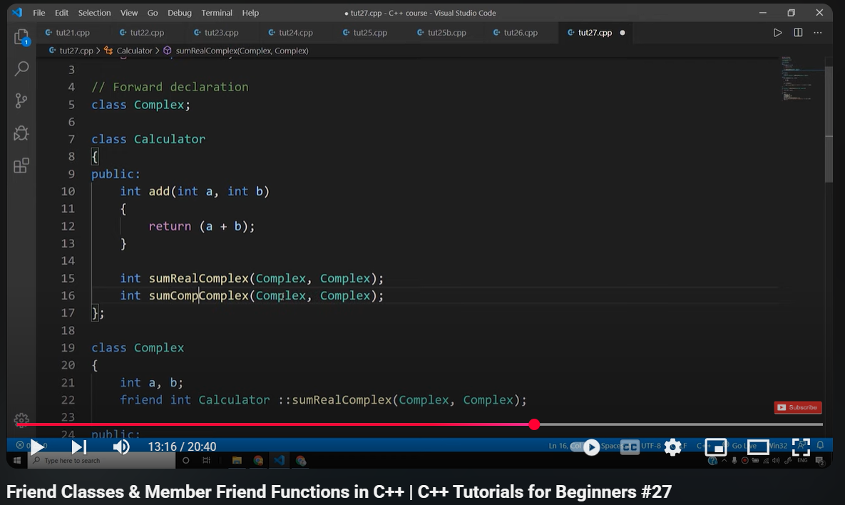
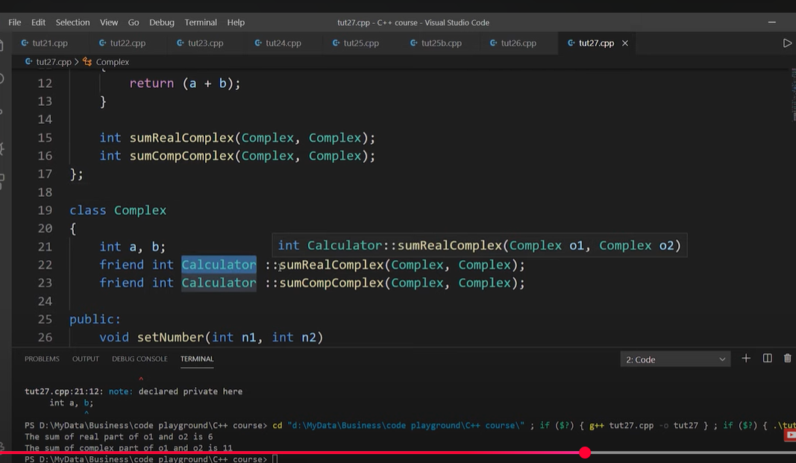
static keyword
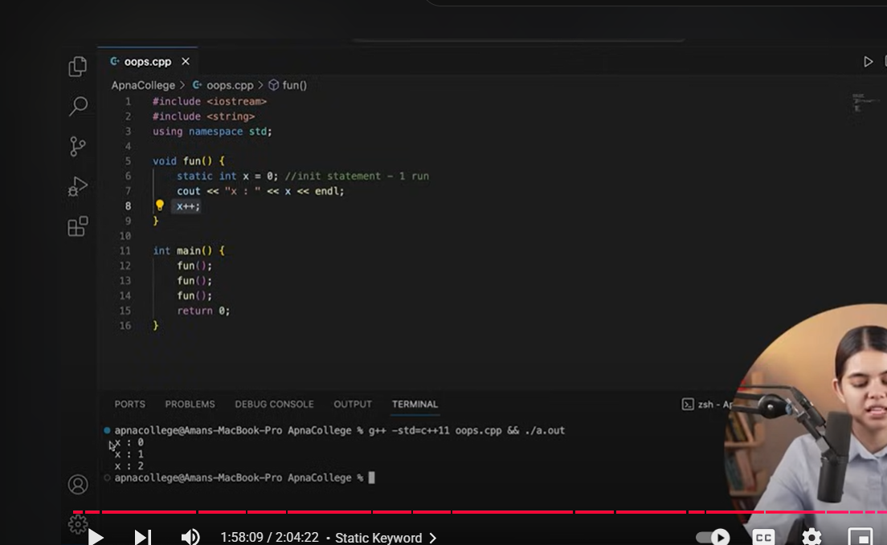
static keyword
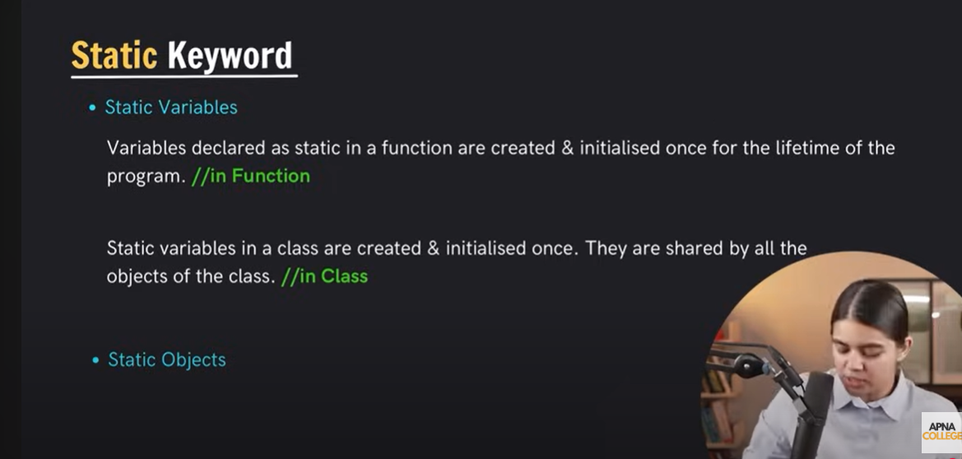

pointers
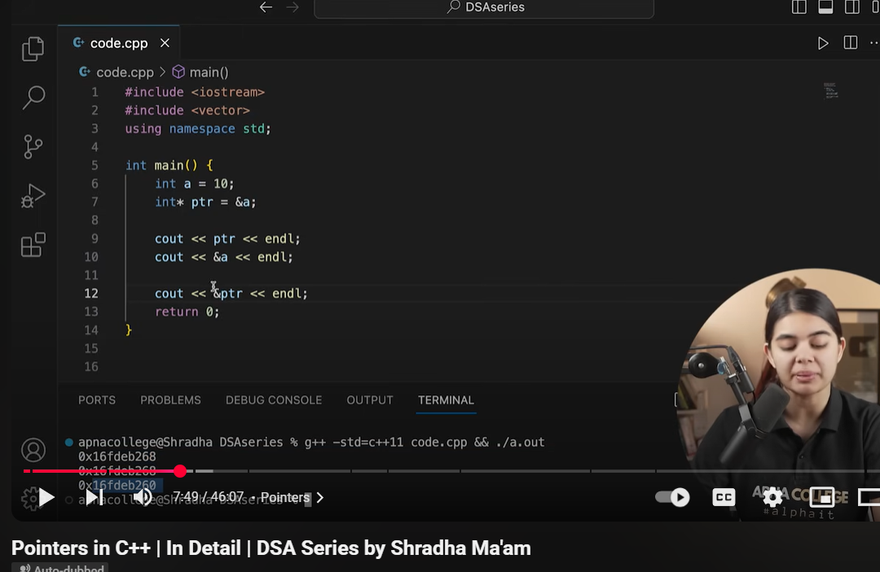
pointer to pointer
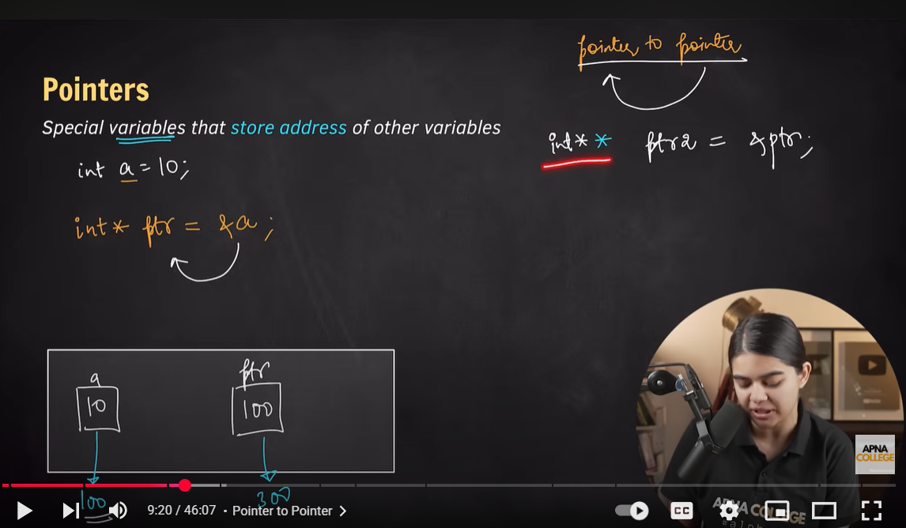

Dereference op
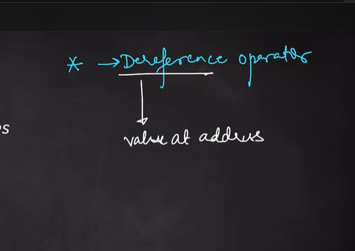
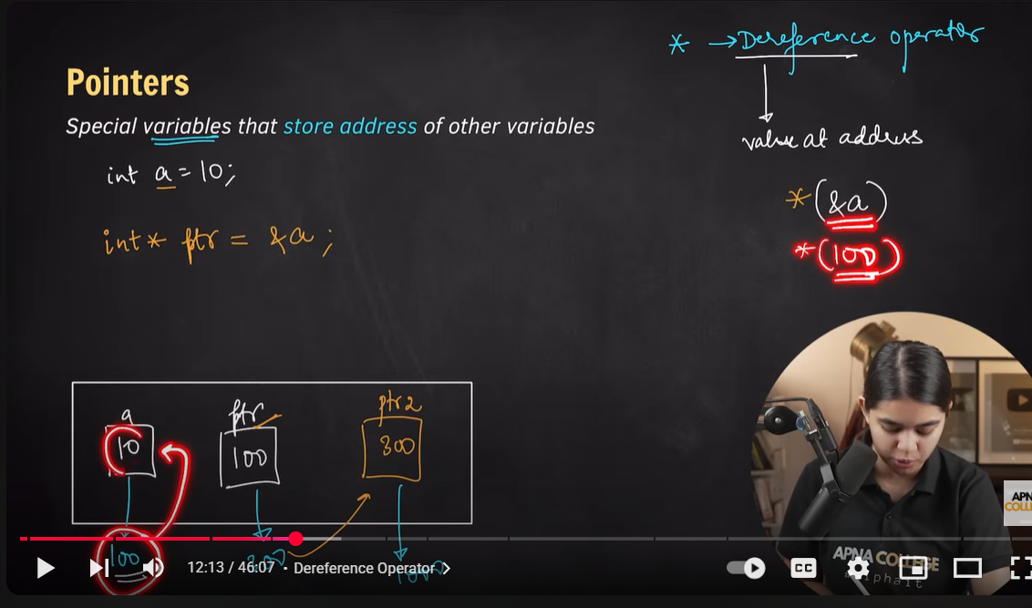
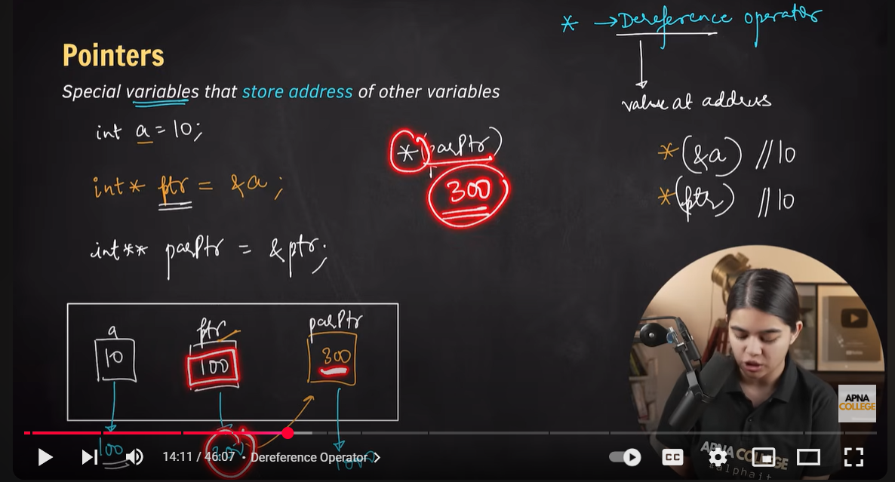

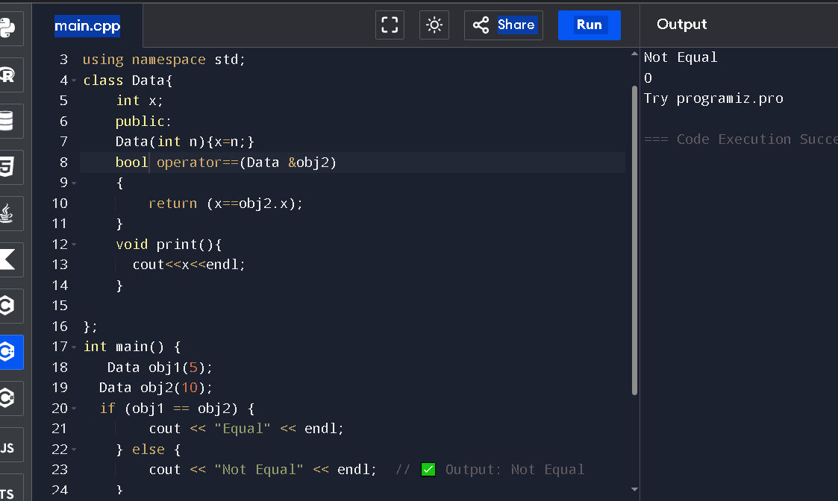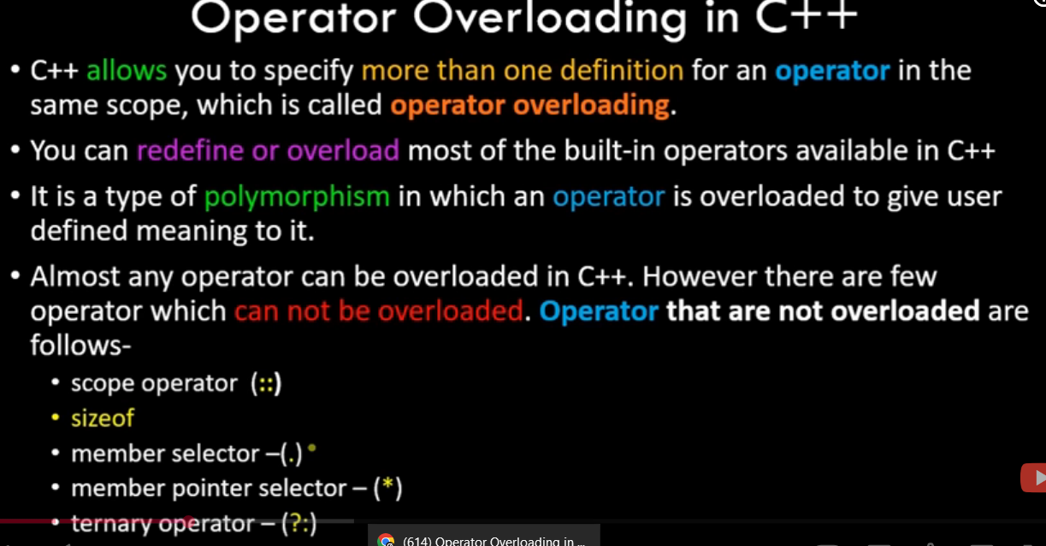
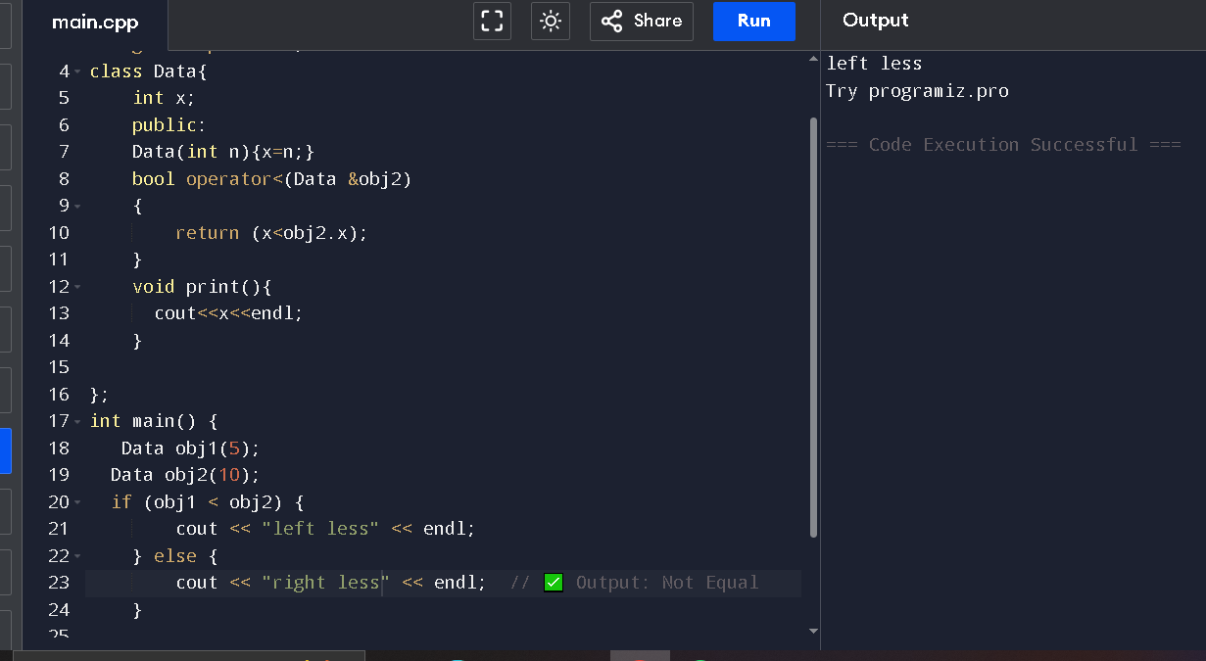
// Online C++ compiler to run C++ program online
#include <iostream>
using namespace std;
class Data{
int x;
public:
Data(int n){x=n;}
bool operator<(Data &obj2)
{
return (x<obj2.x);
}
void print(){
cout<<x<<endl;
}

};
int main() {
Data obj1(5);
Data obj2(10);
if (obj1 < obj2) {
cout << "left less" << endl;
} else {
cout << "right less" << endl; // ✅ Output: Not Equal
}

std::cout << "Try programiz.pro";

return 0;
}

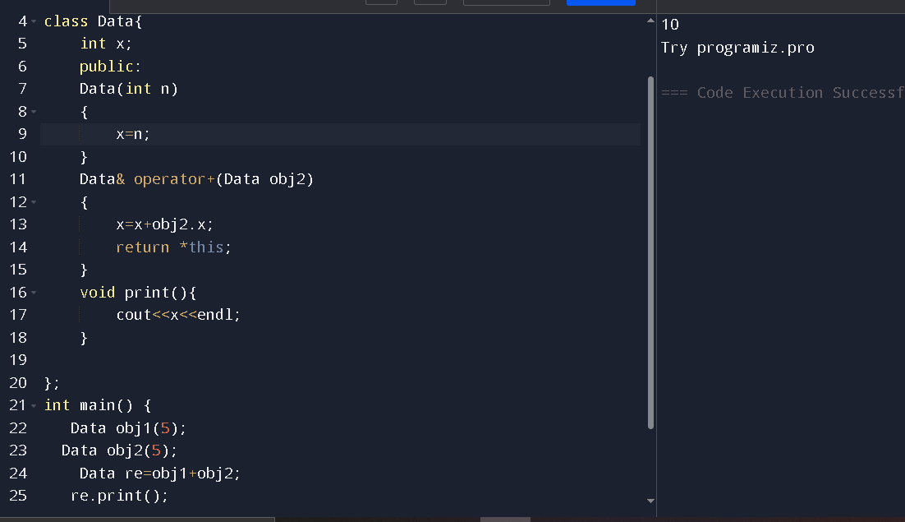
// Online C++ compiler to run C++ program online
#include <iostream>
using namespace std;
class Data{
int x;
public:
Data(int n)
{
x=n;
}
Data& operator+(Data obj2)
{
x=x+obj2.x;
return *this;
}
void print(){
cout<<x<<endl;
}

};
int main() {
Data obj1(5);
Data obj2(5);
Data re=obj1+obj2;
re.print();
std::cout << "Try programiz.pro";

return 0;
}

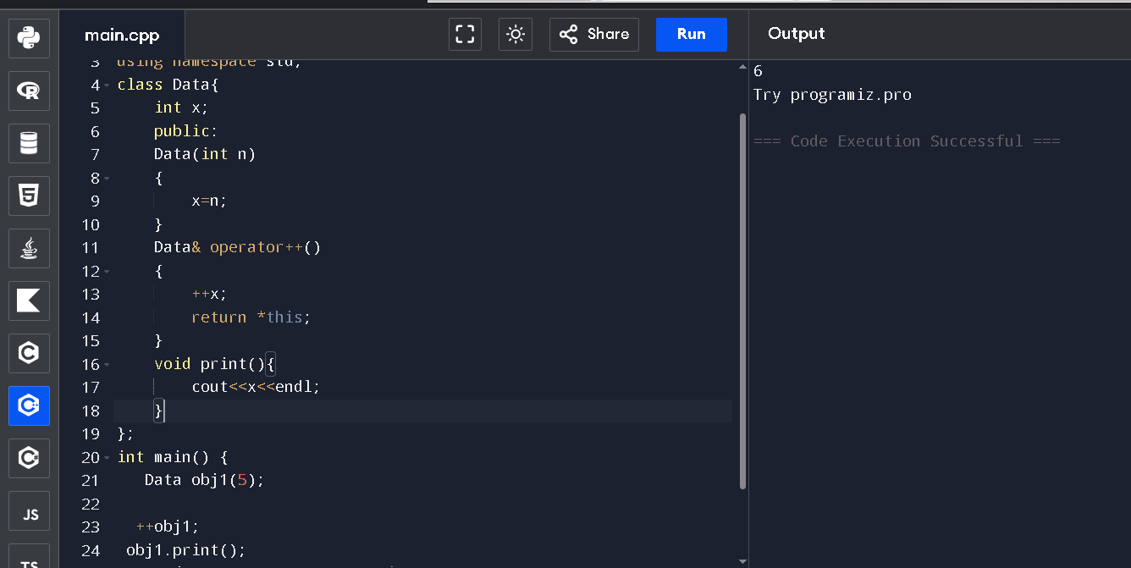
// Online C++ compiler to run C++ program online
#include <iostream>
using namespace std;
class Data{
int x;
public:
Data(int n)
{
x=n;
}
Data& operator++()
{
++x;
return *this;
}
void print(){
cout<<x<<endl;
}
};
int main() {
Data obj1(5);

++obj1;
obj1.print();
std::cout << "Try programiz.pro";

return 0;
}
Insertion / exertion operator overload
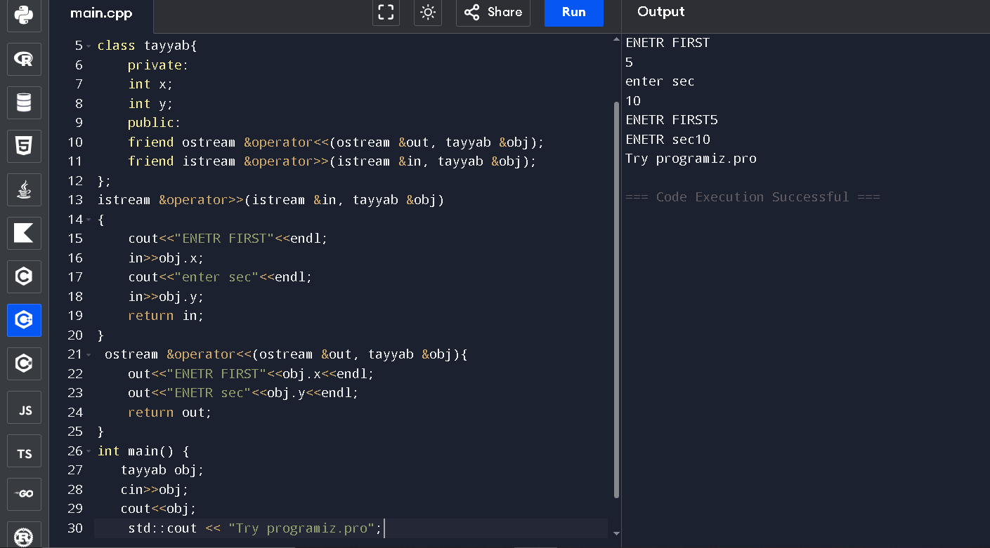

// Online C++ compiler to run C++ program online
// Online C++ compiler to run C++ program online
#include <iostream>
using namespace std;
class tayyab{
private:
int x;
int y;
public:
friend ostream &operator<<(ostream &out, tayyab &obj);
friend istream &operator>>(istream &in, tayyab &obj);
};
istream &operator>>(istream &in, tayyab &obj)
{
cout<<"ENETR FIRST"<<endl;
in>>obj.x;
cout<<"enter sec"<<endl;
in>>obj.y;
return in;
}
ostream &operator<<(ostream &out, tayyab &obj){
out<<"ENETR FIRST"<<obj.x<<endl;
out<<"ENETR sec"<<obj.y<<endl;
return out;
}
int main() {
tayyab obj;
cin>>obj;
cout<<obj;
std::cout << "Try programiz.pro";
return 0;
}

https://youtu.be/ZbXk-oxTXUw?si=lYHxgkDG5f_u8KNX
link for operator overloading
